ASSIGNMENT: 2

1. Create a file like nano file1.txt

I created a file using nano command but named it as sample 1

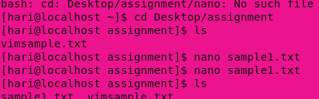

o Edit some data and then save the file

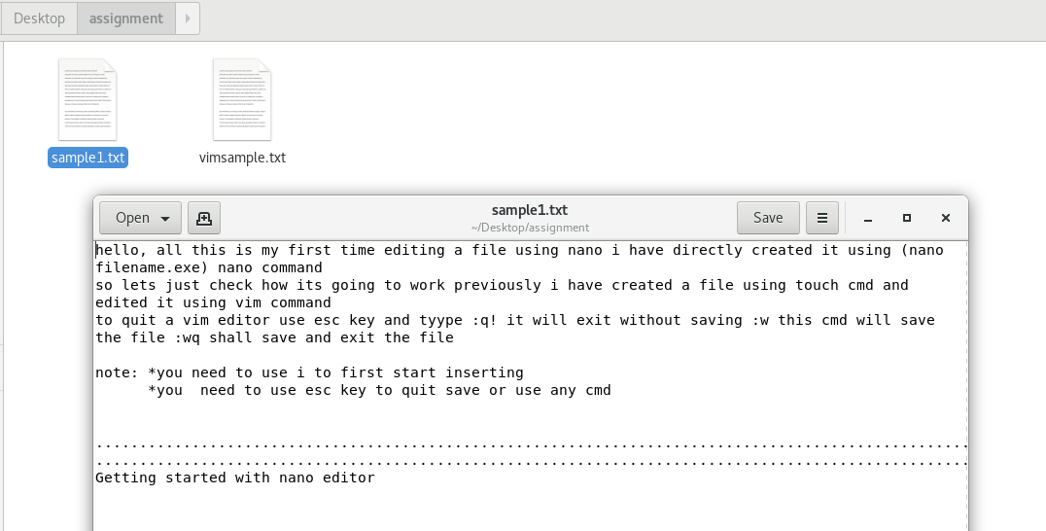

1. Now we will copy date from file1 to new file2

o cp file1.txt file2.txt

copied 1 file to other using above command



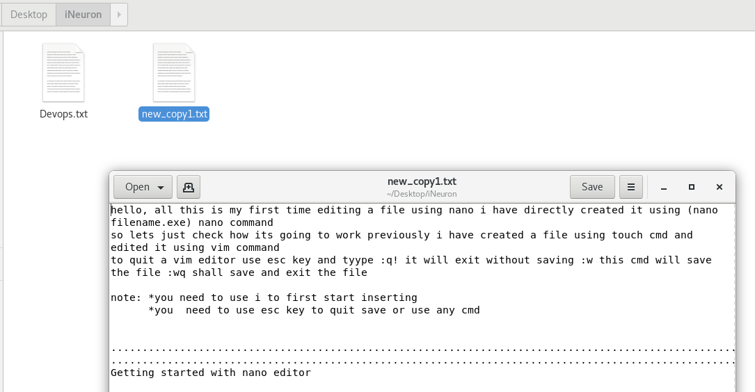

o Then see the output of file2.txt, cat file2.txt

* The above command has given the content present in the text file

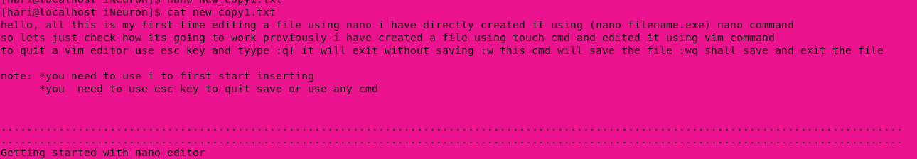

1. Now we will move the file2.txt to new folder /home

Permission is denied for me to move the file to home folder



Now I tried it in a different way and its working



4. Then we create a new file3.txt and file4.txt in home directory and add

content in it.

o Now do echo “Hello I am newline” > file3.txt and provide the

output of file3.txt

o Now do echo “Hello I am newline” >> file4.txt and provide the

output of file4.txt

o Tell the different between both step you follow and the reason

behind it

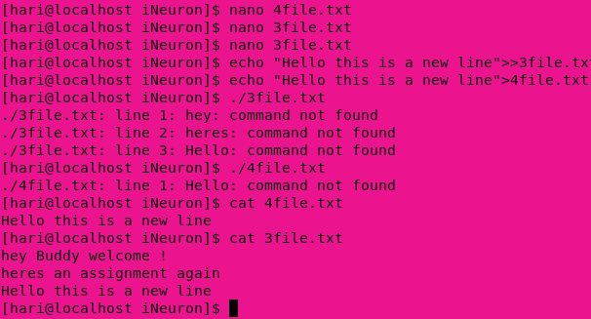

* The difference I found is that when we use single > it will replace the existing text in the text file
* If we use double >> it will append the text file with new text

5. For remove a file or directory you can use the below two commands

o To delete a file – rm <any_filename>

o To delete a folder – rmdir <any_foldername>

its returning command not found if I use -rm or -rmdir so I am current file or folder using only rm or rmdir for removing files and folders respectively